Exp 1: Analysis Development and Verification of 8 bit and 16 bit Arithmetic operation using Assembly Language program
Objective
- To Develop and Verify 8 Bit Addition and Subtraction
- To Develop and Verify 16 bit Addition and Subtraction
- To Develop and Verify 8 bit Multiplication and Division
- To Develop and Verify 16 bit Multiplication and Division
Components Required:
8085 Simulator (or )8085 intel microprocessor
Procedure
- Open the 8085 simulator.
- Enter the required assembly language program.
- Enter the input data into the specified memory locations.
- Execute the program step by step or run it.
- Check the accumulator and register contents after execution.
- Verify the result stored in the specified memory location.
- Repeat the same procedure for 8-bit and 16-bt addition, subtraction, multiplication and division.
- Record the results and compare them with the expected output.
- To Develop and Verify 8 Bit Addition and Subtraction
- To Develop and Verify 8 Bit Addition and Subtraction
- To Develop and Verify 8 bit Addition and Subtraction
8-bit Additon
Program
LDA 2050H
MOV B,A
LDA 2051H
ADD B
STA 2052H
HLT

Output: 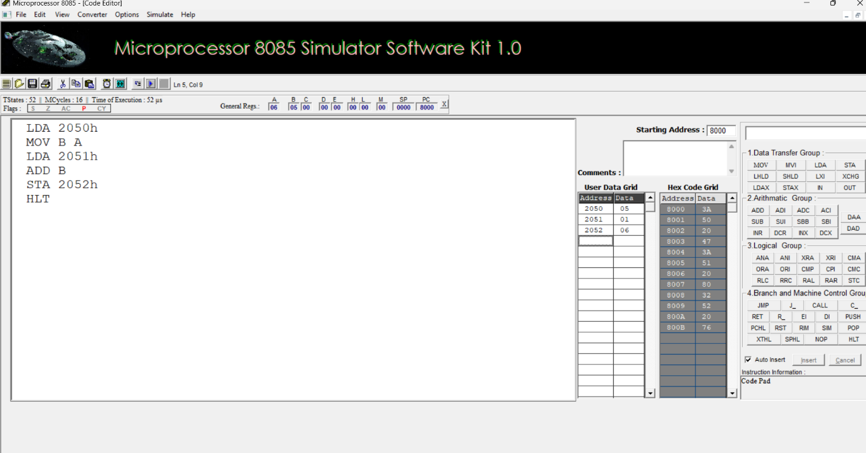

Memory Address:
Address | Data
2050 | 05
2051 | 01
2052 | 06

8-bit Subtraction
Program
LDA 2050H
MOV B,A
LDA 2051H
MOV C,A
MOV A,B
SUB C
STA 2052H
HLT
OUTPUT
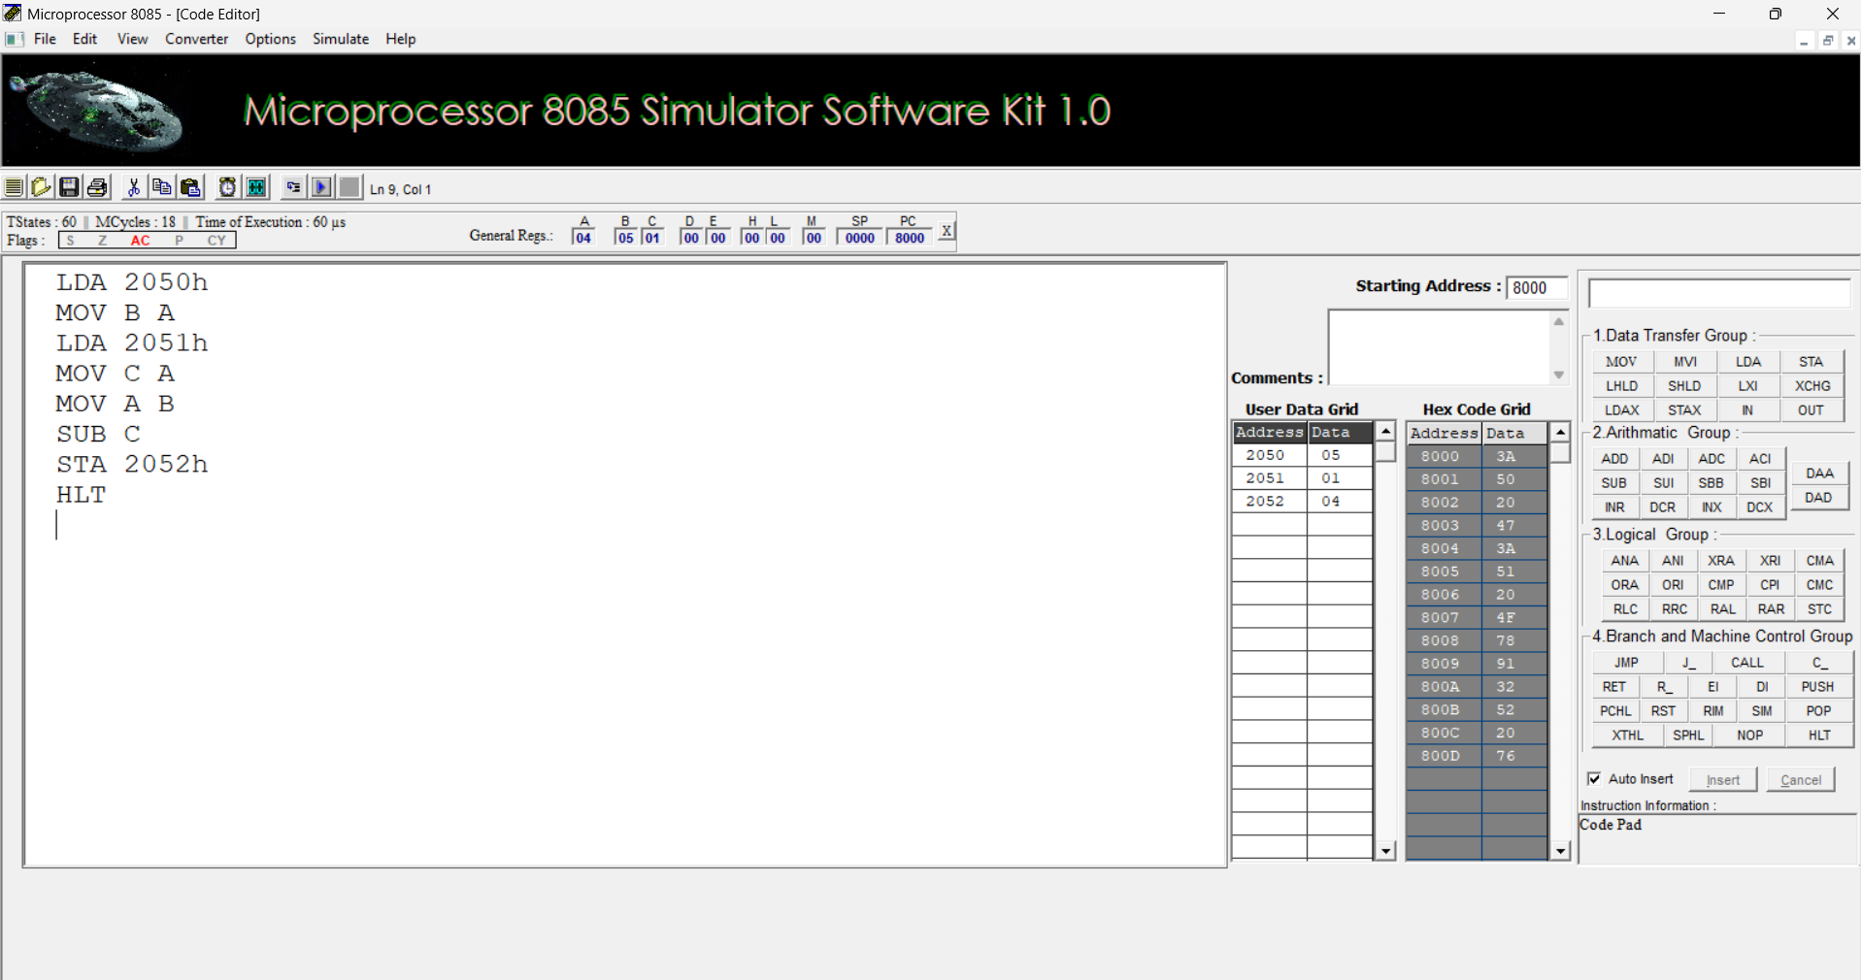

Memory Address:
Address | Data
2050 | 05
2051 | 01
2052 | 04

- To Develop and Verify 16 bit Addition and Subtraction
16-bit Additon
Program
LHLD 2050H
XCHG
LHLD 2052H
DAD D
SHLD 2054H
HLT
OUTPUT :

Memory Address :
16-bit Subtraction
CODE
LHLD 2050H
XCHG
LHLD 2052H
XCHG
MOV A,L
SUB E
MOV L,A
MOV A,H
SBB D
MOV H,A
SHLD 2054H
HLT
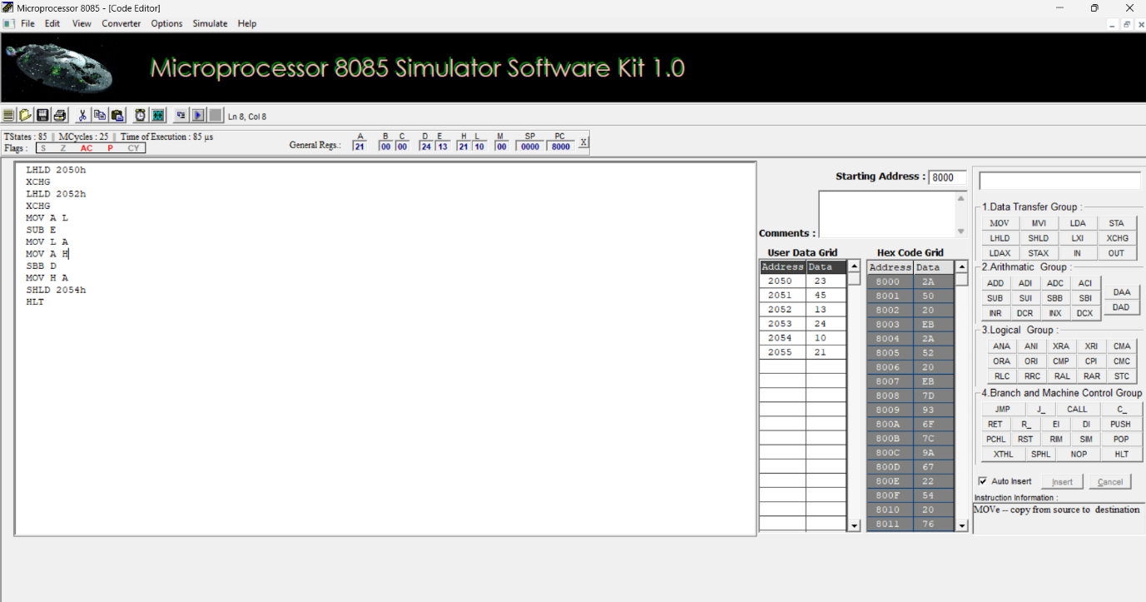
Output:

Memory Address:
Address | Input Data
2050 | 23
2051 | 45
2052 | 13
2053 | 24
2054 | 10
2055 | 21

- To Develop And Verify 8 bit Multiplication And Division
8 bit Multiplication
Program :

LDA 2050H
MOV B,A
LDA 2051H
MOV C,A
MVI D,00H
MVI A,00H
LOOP: ADD B
DCR C
JNZ LOOP
STA 2052H
MOV A,D
STA 2053H
HLT
OUTPUT:
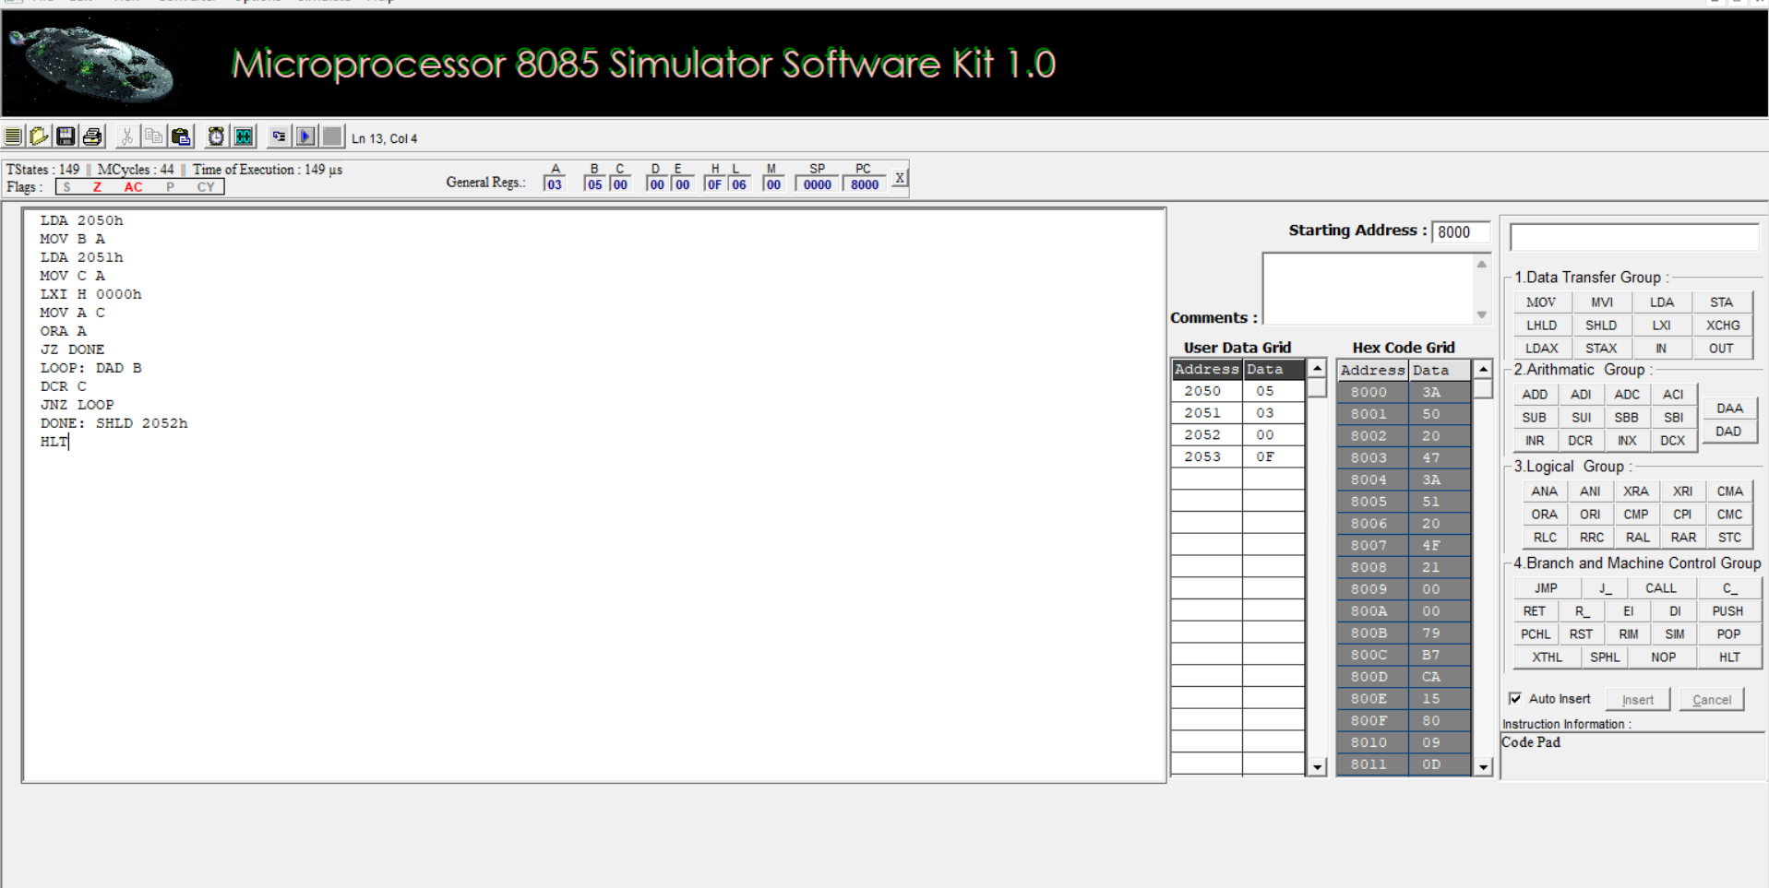
Memory address:
Address | Data
2050H | 05
2051H | 03
2052H | 0F
2053H | 00

8 bit Division
Program:
LXI H 2050h
MOV B M
MVI C 00h
INX H
MOV A M
LOOP: CMP B
JC DONE
SUB B
INR C
JMP LOOP
STA 3050h
DONE: STA 3050
MOV A C
STA 3051h
HLT
OUTPUT:
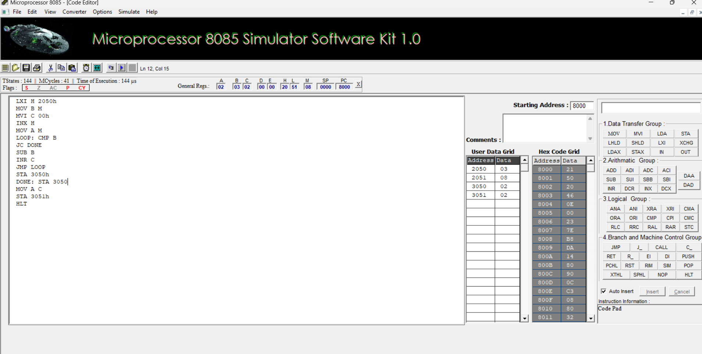
Memory Address
Address | Data
2050H | 03
2051H | 08
3050H | 02
3051H | 02
- To Develop and Verify 16 bit Multiplication and Division
16 bit Multiplication
Program :
LHLD 2050h
XCHG
LHLD 2052h
SPHL
LXI H 0000h
LXI B 0000h
LOOP: DAD SP
JNC NEXT
INX B
NEXT: DCX D
MOV A E
ORA D
JNZ LOOP
SHLD 2054h
MOV L C
MOV H B
SHLD 2056h
HLT
OUTPUT:
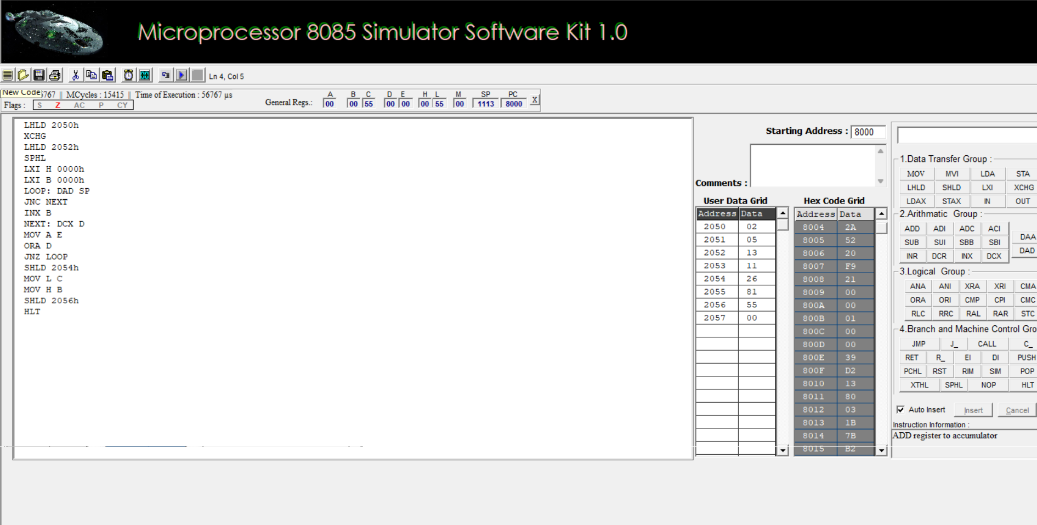
Memory Address
Address | Data
2050 | 02
2051 | 05
2052 | 13
2053 | 11
2054 | 26
2055 | 81
2056 | 55
2057 | 00
16 Division
Program
LXI B 0000h
LHLD 2052h
XCHG
LHLD 2050h
MOV A L
200B: SUB E
MOV L A
MOV A H
SBB D
MOV H A
JC 2017
INX B
JMP 200B
2017: DAD D
SHLD 2056h
MOV L C
MOV H B
SHLD 2054h
HLT
OUTPUT:
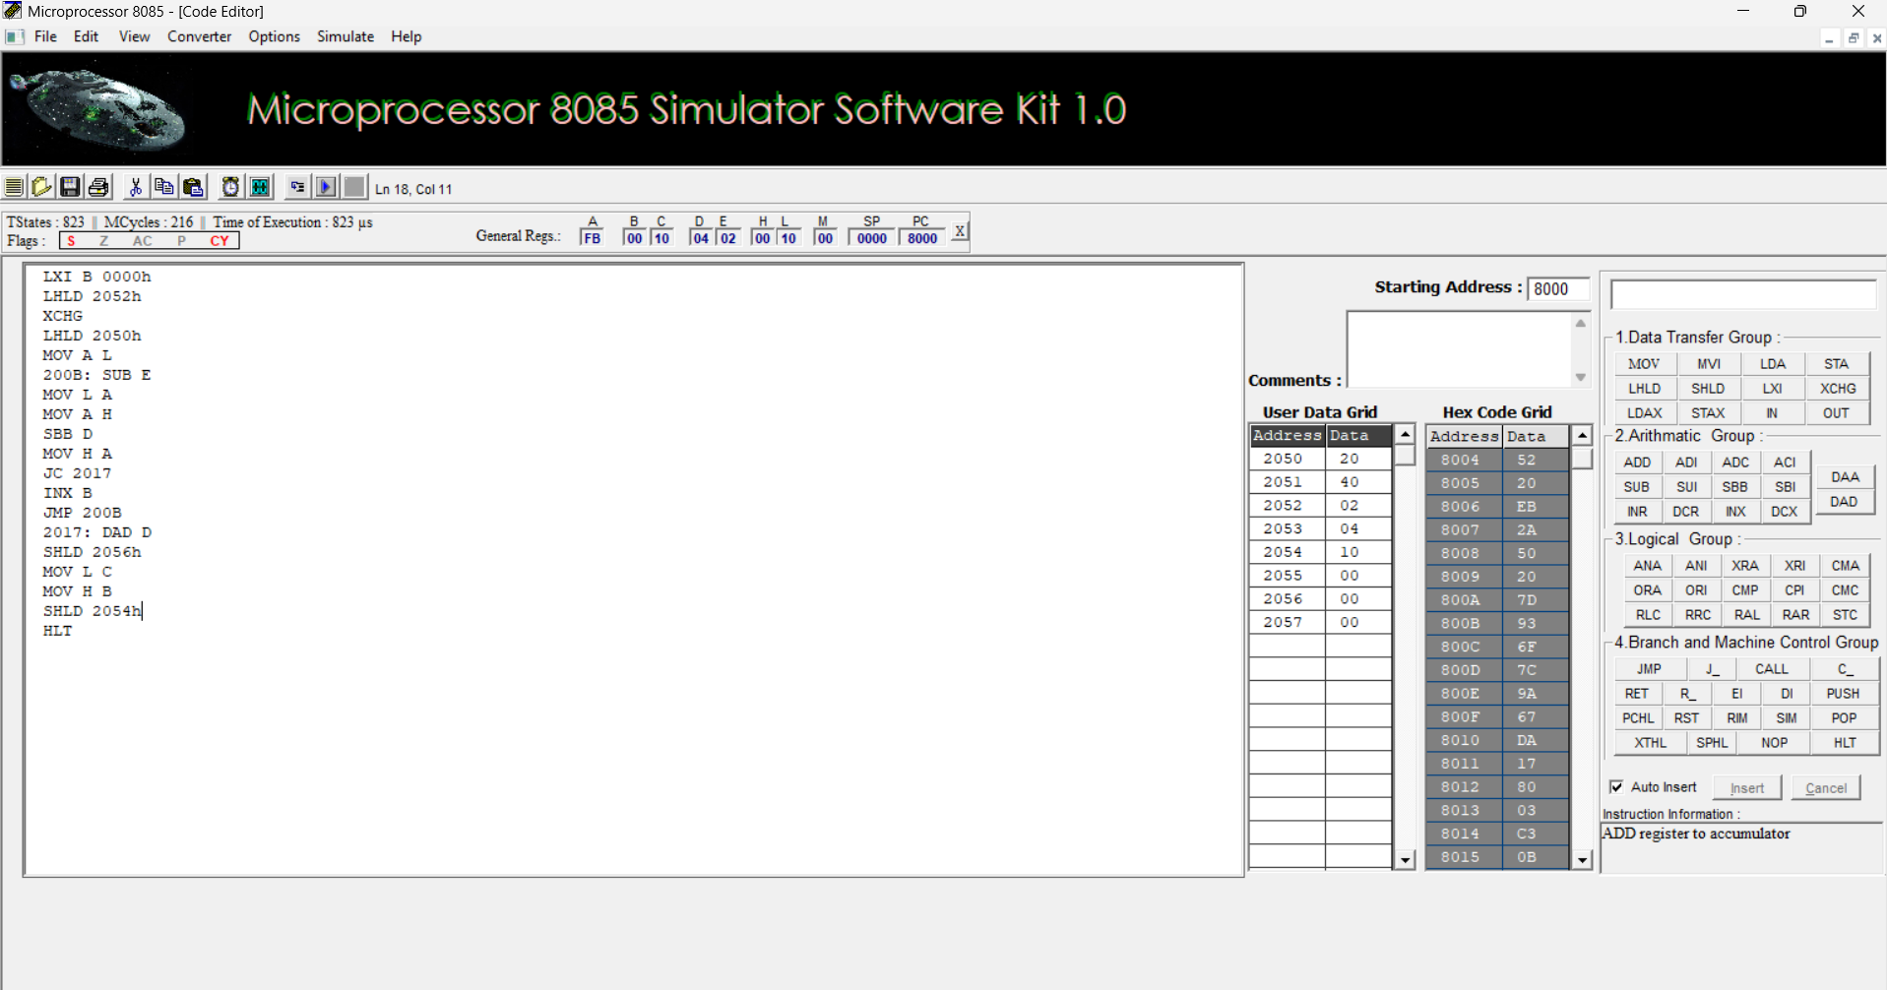
Memory Address:
Address | Data
2050H | 20
2051H | 40
2052H | 02
2053H | 04
2054H | 10
2055H | 00
2056H | 00
2057H | 00

